NDIS Workforce Capability Framework Information Pack
A guide to the Framework
April 2023

Overview
This document has been written by the NDIS Quality and Safeguards Commission.
The NDIS Workforce Capability Framework (the Framework) has been developed with significant consultation, and is valuable for participants, providers and workers involved in National Disability Insurance Scheme (NDIS) work. Contributions to the Framework’s design and development, including feedback, are also acknowledged as having been integral to this process.
The Framework can also assist those thinking about a rewarding career in the disability sector, and learning and training organisations can use the Framework to help shape their curriculum in the new way of delivering disability supports through the NDIS.
This promotional pack provides further information on the Framework, its purpose, how it can be used, its value and a summary of the resources available. There are tools, downloadable guides and templates that support the application of the Framework by different users including providers, workers, job seekers and participants.
Where aspects of the Framework itself is written from a participant perspective, there will be an example, and the tool will clearly state ‘I’, ‘you’ or ‘we’ as relevant.
Visit the Workforce Capability Framework website for the latest tools, resources and news.

In this pack:
Overview 1
What is the Workforce Capability Framework? 3
Who was consulted when developing the Framework? 3
How can the Framework be used? 4
Who can use the Framework? 4
What are the tools and resources that support the Framework? 5
Tools and resources for workers 6
Career Options Guide 6
Self-Assessment Tool for Potential Workers 6
Tools and resources for participants 6
Participant resources 6
Tools and resources for participants and service providers 7
Position Description Tool 7
Supervising for Capability 7
Recruitment and Selection Resources 7
Tools and resources for service providers 8
Training for Capability Guide 8
Workforce Management and Planning Tool 8
How does the Framework relate to the Code of Conduct and Practice Standards? 9
Who can I contact for more information? 9

What is the Workforce Capability Framework?
The NDIS Workforce Capability Framework (the Framework) describes the attitudes, skills and knowledge expected of all workers funded under the NDIS. It provides clear, practical examples of behaviours that demonstrate a worker’s capability and establishes a shared language of ‘what good looks like’. The Framework is supported by tools and guides to assist providers, existing and potential workers, job seekers and participants.
The Framework:
- Is written from the perspective of the NDIS participant.
- Translates the NDIS Code of Conduct and Practice Standards into observable behaviours and capabilities for workers at all levels.
- Describes the attitudes, skills and knowledge (the capabilities) expected of all workers with a strong focus on worker and participant relationship and interactions.
- Describes ‘what good looks like’ when upholding the rights-based values of the NDIS to drive positive culture change.
- Is written with a focus on inclusion, choice and control, and upholding the rights of people with disability.
- Relevant to all workers providing NDIS-funded supports and services to NDIS participants, including:
  - Day-to-day personal support work (such as assistance with daily tasks or personal care)
  - Specialised supports, capacity building supports (such as health and therapeutic supports)
  - Leaders and managers, and
  - Ancillary services (such as maintenance, cleaning or reception).
- Designed for anyone who needs to understand, direct or participate in the NDIS workforce.
If workers at all levels demonstrate the capabilities set out in the Framework, participants should receive safe and quality services that support their chosen goals.

Who was consulted when developing the Framework?
The Framework was developed over an 18-month period of multi-stage consultation with more than 600 people including:
- participants/carers/family members
- workers
- service providers
- peak bodies
- technical experts/researchers and training providers.

How can the Framework be used?
The Framework is written in the participant voice and describes ‘what good looks like’ for delivering and receiving supports. ‘You’ and ‘your’ refers to the worker or provider, and ‘me’ and ‘I’ refers to the participant.
The Framework has five objectives that describe the core expectations participants have of workers and providers.
These include:
- Our Relationship: Set up our relationship for success.
- Your Impact: Know your capabilities, role and impact.
- Support Me: Support me to pursue what’s important to me.
- Be Present: Be present and provide the support I need.
- Check In: Work with me to evaluate and act on what is working and what is not.
The interactive website version of the Framework invites the user to select the type of work they want to describe (general, advanced, ancillary, managerial, leadership) and displays the relevant capabilities.
The tools and resources that support the Framework come from a capability-based approach to workforce planning. Every tool uses the framework capabilities in practical ways to improve workforce quality.
The NDIS Workforce Capability Framework is available online and as a downloadable PDF or accessible Word document.

Who can use the Framework?
The Framework can be used by many people, including workers, participants, service providers and potential workers.
Participants who want to be a part of recruitment, supervision or providing feedback can use the Framework, and so can self-managing participants.
Workers who want to expand their career or potential workers wanting to see what a career in disability supports could look like, can use the Framework.
Providers and human resources workers can use the Framework to workforce plan and manage, recruit, supervise and identify training options for workers.

What are the tools and resources that support the Framework?
The Framework is supported by tools and guides that assist in areas such as career planning, recruitment, workforce planning and management and workforce development.
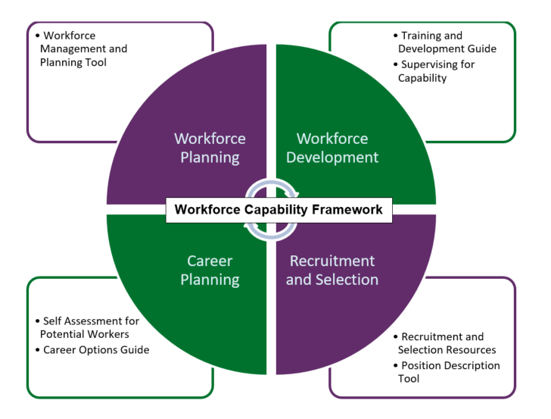

Tools and resources for workers

Career Options Guide
- Helps workers to explore work and career opportunities in disability and related sectors.
- Draws on the Framework to describe expectations for different roles, as a basis to understand where to apply and develop capabilities and interests.
- Provides tips and suggestions about how to use general disability support work capabilities in new ways and how to build on these capabilities to deliver different aspects of support, take on more specialised roles or move into frontline management positions.
- Useful for: NDIS workers interested in exploring work options and developing their capabilities and career further.

Self-Assessment Tool for Potential Workers
- Provides job seekers with an outline of what working in a disability support role could look like.
- Uses questions and practical scenarios to support users to reflect on their attitudes, values and beliefs to help them decide if they are a good fit for working in a disability role.
- Identifies existing training, skills and life experience that could equip a person for working in the disability sector.
- Provides a tailored assessment, based on user responses and outlines general advice on next steps to take.
- Useful for: people considering working in the NDIS.

Tools and resources for participants

Participant resources
- Provides practical guidance for participants about using the Framework and tools to support them to find and keep the workers they need.
- Easy read resources, videos and animations are available for key documents and processes.
- Scenarios showing aspects of the Framework and tools in use are throughout the website to support participants in finding and keeping workers.

Tools and resources for participants and service providers

Position Description Tool
- Guides the user to develop a capability-based position description.
- Automatically loads relevant Framework capabilities based on the role and position information.
- Useful in building consistent and capability-based understanding of worker roles.
- Supplies two versions tailored to provider and participant needs.
- Is downloadable for further editing.
- Useful for: NDIS providers and participants self-managing their own supports or those involved in describing a support role.

Supervising for Capability
- Provides practical guidance and tools to raise quality and consistency of supervision.
- Provides tip sheets, checklists and templates to support senior leaders, supervisors, workers and participants to engage in supervision.
- Allows templates and documents to be downloaded and edited to suit individual needs.
- Useful for: NDIS providers, supervisors, workers and participants in feedback and supervision processes.

Recruitment and Selection Resources
- Provides step-by-step guidance and tips on taking a capability-based approach to recruiting and selecting workers.
- Provides information, practical tips, templates and materials for each stage of the recruitment process.
- Allows templates and documents to be downloaded and edited to suit individual needs.
- Supplies two versions tailored to provider and participant needs.
- Useful for: NDIS providers and participants self-managing their own supports or those involved in engaging supports.

Tools and resources for service providers

Training for Capability Guide
- Supplies advice to NDIS providers on sourcing training to support development of capabilities.
- Provides practical guidance on reviewing capabilities in the workforce and assessing where there are gaps.
- Steps through how to find training that addresses capability gaps in a provider’s workforce.
- Useful for: NDIS providers seeking to upskill their workforce and ensure training is targeted to the needs of workers and focused on capability.

Workforce Management and Planning Tool
- Supports NDIS providers to assess their current workforce management practices and plan for the workforce they need now and into the future.
- Provides a detailed workforce plan based on the information entered into the tool.
- Useful as a checklist to confirm what to consider in workforce planning and/or as a source of ideas on how to incorporate the Framework into the planning process to address workforce challenges and develop strategies to address them.
- Available in Excel as a downloadable template.
- Useful for: NDIS providers.

How does the Framework relate to the Code of Conduct and Practice Standards?
The Framework has been built to support participants, providers, workers, and trainers.
The NDIS Code of Conduct requires workers and providers delivering NDIS supports to “provide supports and services in a safe and competent manner with care and skill.”
Under the Practice Standards, registered providers are required in the Human Resource Management module to meet the outcome: “Each participant’s support needs are met by workers who are competent in relation to their role, hold relevant qualifications, and who have relevant expertise and experience to provide person-centred support.”
The Framework provides the guidance and tools to support NDIS providers to meet these obligations.

Who can I contact for more information?
For more information about the NDIS Commission’s Workforce Capability Workforce Capability Framework or its implementation, visit the Workforce Capability Framework website: Home of the NDIS Workforce Capability Workforce Capability Framework | NDIS Workforce Capability (ndiscommission.gov.au).
Project contact: workforcecapability@ndiscommission.gov.au or 1800 035 554.

National Disability Insurance Scheme (Quality Indicators for NDIS Practice Standards) Guidelines 2018 (2021). National Disability Insurance Scheme (Quality Indicators for NDIS Practice Standards) Guidelines 2018 (legislation.gov.au)

