Tip sheet - Interview questions
The NDIS Workforce Capability Framework (the Framework) website has a detailed guide on recruitment for participants who are finding workers. You can view a tutorial on how to use the guide.
Interviews are one way to find out more about a person when looking for the right worker for yourself. Interviews can help you choose support workers, allied health workers, support co-ordinators and providers.

Writing interview questions
Interview questions should try to find out how a worker will use their skills and knowledge when supporting you. They may talk about how they worked with other people. The behaviour, skills and knowledge of a worker are called capabilities.
The Framework describes ‘what good looks like’ for participants when they receive NDIS supports and services. You can use the Framework to identify what capabilities you need from workers and providers.
Choose two or three capabilities from the Framework when deciding what questions to ask. For example, one of the capabilities in the Framework is Uphold my rights.
The capability in the Framework says:
Uphold my rights
Respect my right to privacy. Ask for my permission before collecting, using or disclosing information about me.
If you wanted to ask a question about this capability, you could ask:
“Tell me about a time you had to protect someone’s privacy and keep personal information safe. How did you manage this? How important would you say confidentiality is in your job as a support worker?”
Using the Position Description Tool can help you choose what capabilities are important to you. It also helps you describe the key jobs a worker will do. The position description you create can help you decide what interview questions to ask.

Format of questions
Questions in an interview are commonly asked in two ways. Each one aims to get the worker to share their knowledge and the actions they would take.
Scenario based questions ask the worker to explain what they would do in a situation that you describe. For example:
“My boyfriend often stays overnight. As a worker coming in the morning to assist me, how would you respect my privacy?”
Experience based questions ask the worker to tell you what they have done in the past and the result of their action. For example:
“Tell me about a time when a person you worked with wanted to do something you did not agree with. What did you do in that situation? What happened?”
Questions should get the worker to tell you the action they took or might take, and the result they got or hope to get. It is important the person gives an example of how they would do something, not just say they can do it. This allows you to decide whether the action they took in that scenario is what you would have wanted.
The diagram below shows how a question and answer should flow. The right column is using a scenario, and the left column is asking about experience.
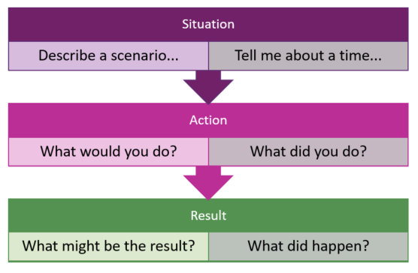

Know the answers you want
Make notes on what you want in an answer. This can give you an idea of what a good response might be. This can help you:
- Compare answers from different people
- Score answers – is it a poor, good, or very good answer?

Examples

Question on privacy
“Tell me about a time you had to protect someone’s privacy and keep personal information safe. How did you manage this? How important would you say confidentiality is in your job as a support worker?”
Look for answers that show the following:
- Experience of checking what can be shared and with whom
- Understanding of the boundaries of support work and not sharing outside of work
- Planning ahead for emergency situations
- Respect for participants wishes.
Here is an example of a poor, good and very good answer:
Poor: I have only asked for information that I need. I tell participants not to give me personal information.
Good: I checked with the participant about what personal or medical information they wanted to keep confidential. If a provider or family ask for information, I will check with the participant first for what information I can share.
Very good: I do not discuss participant’s personal details with other participants or people outside of work. When asked by others, I checked with the participant before sharing information.
For example, when I start working with a new participant, I develop a plan with them. The plan outlines whom I can share information with and what information I can share during an emergency.

Question on choice and control
“Tell me about a time when a person you worked with wanted to do something you did not agree with. What did you do in that situation? What happened?”
Look for answers that show the following:
- An understanding of a participant’s right to choice
- Working with participants to manage any risk without taking choice away
- A good outcome from what happened.
Here is an example of a poor, good and very good answer:
Poor: I assessed the activity as too risky and told the participant that they should not do it.
Good: I acknowledged the participant had the right to undertake the activity and helped them do it.
Very good: I acknowledged the participant had the right to undertake the activity but also worked with them to understand the risks with their choices. I supported the participant to undertake the activity with agreed safety measures in place.

Question on supporting identity
“My Chinese heritage and traditions are important to me. How would you support me to do activities that consider my cultural identity?”
Look for an answer that shows the following:
- Understanding of the importance of cultural needs
- Knowledge of culturally tailored supports and services
- Examples that shows inclusive behaviour.
Here is an example of a poor, good and very good answer:
Poor: I would ask the person what they want to do.
Good: I respect individual differences. I would talk with you about what is important to you, what interests you and when you would want to do some of those activities.
Very good: I would ask you what you preferred and would meet your preferences wherever possible. I will spend time learning about your history and activities in your area. I would ask you to choose which ones you liked and support you to attend.
I would check in with you to see if you enjoy the activity or group. I would also see if there is anything else you would like to do or try that I am not aware of.

Question on supporting health needs
“Tell me about a time you managed a stressful situation related to a person’s health needs, particularly a high intensity health related support need like doing peg feeds or trachy care?”
Look for answers that show the following:
- An understanding, knowledge and experience of high support health needs and the training that may be required
- Example of implementing a health support plan and engaging with the person in the plan
- Ability to respond in a stressful environment
- Good record keeping.
Here is an example of a poor, good and very good answer:
Poor: I don’t understand what high intensity supports are. I was doing multiple tasks for a participant and found it stressful.
Good: I have supported a person with high health support needs. I did training on the health needs of the participant and followed a support plan. I checked in with the participant when they felt unsure. I have successfully supported the participant when they were sick.
Very good: I have supported participants who have high health support needs. I have done training on different health supports for participants. I have worked with a participant in an emergency situation where the health of the participant was at high risk of hospitalisation. I followed the health plan and had a plan in place to manage my stress. I would regularly check in with the participant.
I kept hand over notes to keep everyone aware of the persons’ needs.
Visit the Tips for doing interviews and assessments for more information on having a good interview experience.

