Tip sheet – Having problems with supports?
You have the right to speak up, give feedback or complain about the supports and services you receive if they are not working as they should.
The NDIS Workforce Capability Framework (the Framework) describes ‘what good looks like’ for participants when they receive NDIS supports and services. You can use the Framework to identify what skills your worker or provider is expected to show.

You can give feedback to your worker or provider
You can talk with your workers or providers about your needs, and what you expect. The supervision resources for participants have tip sheets and checklists to show how to give feedback.
The tip sheets have:
- Questions to ask workers that help them do their job better
- Examples of how to give feedback to workers about what they need to do better.
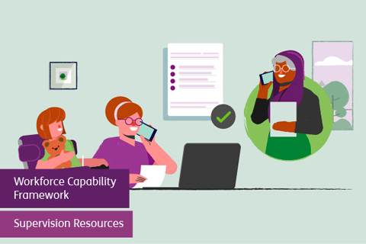

You can get help from an advocate, friend or family
Disability advocates can help you to raise issues with an NDIS provider. They can:
- Help you plan what to say
- Be with you when you speak to the worker or provider.
An advocate can be a trusted friend or family member, or a person from an advocacy organisation. You can find your nearest free disability advocacy service on Ask Izzy - Disability Advocacy Finder | Ask Izzy.

You can tell the NDIS Commission
You can talk to us or your provider when something goes wrong with your supports or services. The NDIS Commission takes complaints if an NDIS funded service or worker has not followed the NDIS Code of Conduct.
You can also talk to us if you don’t want to speak to your provider or you are not happy with how your provider dealt with your complaint.
Make a complaint by completing the complaint contact form or calling 1800 035 544.

You can change provider or worker
You can change provider or hire a new worker. This can be hard and you might want help from an advocate or trusted person.
Make sure you understand any service agreements or employment contracts you have, and what that might mean for ending support. It is important to talk with the provider or worker to plan a transition and handover to a new provider or worker if possible.
You can use the Recruitment and Selection Resources to assist you to find new workers.
