Checklist – Recruiting and choosing a worker
The NDIS Workforce Capability Framework website has a detailed guide on recruitment for participants who are finding workers. You can view a tutorial on how use to the guide.
This checklist goes through the key points to remember when hiring workers.

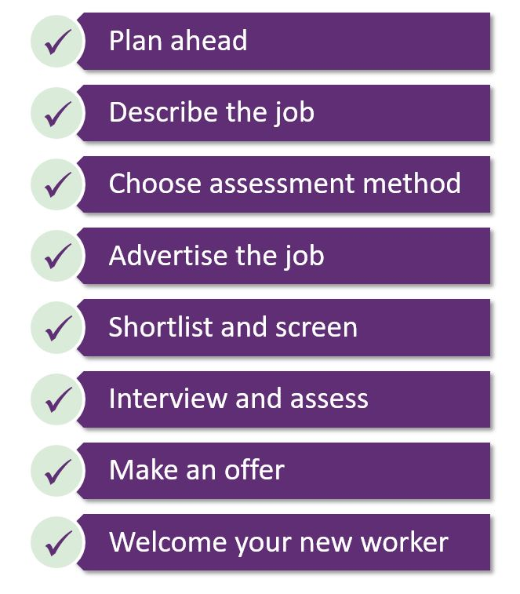

Plan ahead
- Do you need someone to help with choosing and interviewing workers?
- Put key dates in your diary and make sure anyone helping you is available. Key dates include:
  - When to advertise, and receive applications by – the closing date
  - When you plan to do interviews
  - When you want workers to start.
- Think about how will choose workers. Will you interview and do an activity?
- Think about where you might interview workers. Is there a public space you can use?

Describe the job and capabilities
- Do you have a description of the work you need the worker to do?
- A position description lists the tasks of the job as well as skills needed, requirements like worker screening and the expected pay.
- A position description can be created by going to the Position Description Tool.
- Tip: Go to the Pay and Conditions tool from Fair Work Ombudsman for assistance to calculate the pay and conditions when filling out the Position Description Tool.

Choose the right assessment method
- Decide on the way you will assess if a worker is going to be right for you.
  - Will you have an activity planned? For example they could follow instructions to draw a picture, do a role play to follow directions, or make a coffee.
  - Will you contact referees to check their previous work and attitude?
  - Will you do an interview one on one or as a group?
- Write your interview questions and activity. There are downloadable example interview questions and tips for managing interviews and assessments that help you know what to consider when you interview.

Advertise the job
- Use the template to write your job ad.
- Are the key requirements from your position description in the ad?
- Put your ad online, in a local paper, or on a local noticeboard.
- Send or give the ad to friends, family and workers to share.
- Keep track of when you post the ad and when you want to close applications.

Shortlist and screen workers
- You do not need to see or interview everyone who applies for the job.
- Choose who you want to interview by using the downloadable Shortlisting candidates scorecard.
- Shortlist workers based on what they put in their application, their experiences in their resume, and if that matches the skills and experience you are seeking.

Interview and assess workers
- Invite shortlisted workers to an interview at a time that suits you.
- Set up the space you will use for interviews, with anyone who is helping with you.
- Interview the workers you shortlist using the prepared questions and any activities.
- Score the workers using the downloadable Interview and practical test assessment scoring sheet to create your own interview assessment.
- It is a good idea to talk to referees of the workers you want to hire and check they have a NDIS Worker Screening clearance.

Make an offer
- Make a written offer to the worker you choose using the downloadable Letter of Offer template.
- Get your offer accepted in writing.
- Tell people who did not get the role, using the Unsuccessful letter template.

Welcome your new worker
- Meet and welcome your new worker to their role.
- For more information on what to do during your first few meetings with your new worker and setting expectations, visit the welcome your new worker page.
Congratulations on reaching the end of your recruitment process!

