Supervising for Capability
Overview of Resources for Supervisors and Senior Leaders
September 2023
Contents
User icon key 2
Introduction 2
Related supervision resources 3
Using the supervision resources 4
What is in this guide 4
Section 1: Guiding principles 4
Section 2: What is supervision? 5
Section 3: What is in the supervision resources? 6
Other useful resources 7

User icon key
Each document in the NDIS Workforce Capability Framework suite of resources uses one or more icons to show the intended user or users.
Icon | Key
 | NDIS participants
 | Workers
 | Supervisors and frontline managers
 | Senior managers and leaders
 | NDIS providers

Introduction
The approach to supervision described in these resources is focused on building and supporting frontline worker capability. It supports a shared understanding of performance expectations and how workers can be supported to achieve them.
The NDIS is transforming the way disability support is delivered in Australia. Two features that have direct implications for worker supervision are the principle of participant choice and control and an increase in supports delivered in participant home and community settings. Choice and control means that participants expect a say in how workers support them. The shift to providing more support in participants’ own homes and communities means that many workers have little or no day-to-day in-person contact with their manager or the organisation they work for.
Effective organisations know they are only as good as their workers and prioritise ways to recognise, support and develop them. Supportive supervision is one of the best ways to build worker satisfaction, commitment and retention. Effective collaboration between organisations, participants and workers, and supportive supervision practices suited to the NDIS work environment combine to underpin quality participant support, worker satisfaction and workforce stability.
Responsibilities of NDIS providers and workers are set out in the NDIS Code of Conduct and registered providers must also meet the NDIS Practice Standards. Organisations must ensure workers have the capabilities they need, provide appropriate supervision and have policies and systems in place to ensure supports are delivered in a safe and competent manner. The NDIS Quality and Safeguards Commission (the NDIS Commission) developed the NDIS Workforce Capability Framework (the Framework) to describe the required capabilities.

Related supervision resources
This guide is part of a set of ‘Supervising for Capability’ resources developed by the NDIS Commission. You can view the full set of resources on our website or access related resources by selecting the links below. Further useful resources developed by the NDIS Commission are listed at the end of this guide.

Related supervision resources
- Systems to Support Supervision: A Guide for Leaders and Senior Managers
- Supervision and Support Relationship: A Guide for Leaders and Senior Managers
- Working Together: A Guide for Supervisors
- Learning and Capability Development: A Guide for Supervisors

Using the supervision resources
The ‘Supervising for Capability’ resources are a set of guides, tip sheets and templates to guide NDIS providers on how to use the Framework to strengthen the capabilities of workers, supervisors and senior business leaders. Resources cover aspects of supervision that support workforce capability – from setting up organisational policies and systems, to establishing the supervisor-worker relationship, supporting and supervising workers to deliver supports to individual participants and providing relevant learning and development opportunities.
The resources support organisations and supervisors to put systems in place to encourage three-way collaboration between supervisors, workers and participants. A brief statement of purpose is provided on the front page of each guide. For some resources, tailored versions are available for workers and participants that provide more streamlined, targeted information. The colour bar above the title on the front page and the sub-title of each resource indicate the intended users.

What is in this guide
This overview has three sections:
- Guiding principles: describe the values and attitudes that guide supervision in the NDIS.
- What is supervision: defines what is covered in supervision and the supervisory responsibilities addressed by the supervision resources.
- What is in the supervision resources: provides an overview of each of the supervision resources.

Section 1: Guiding principles
Five principles underpin the approach to supervision described in these resources:
- Collaborative: Participants, workers and supervisors collectively agree on ‘what good looks like’ and how they will work together to achieve it.
- Capability-based: The Framework identifies the attitudes, skills and knowledge workers need to provide quality support. They describe both the ‘how’ and the ‘what’ of support.
- Respectful: The interests and aspirations of all parties are understood and respected.
- Supportive: Supervision creates safe and trusted relationships that support worker wellbeing and encourage regular discussion, reflection and development.
- Evidence-based: The organisation uses evidence about how well they are supporting participants and their workers to shape and improve their approach to supervision.
The supervision resources illustrate how these principles can apply to supervising frontline workers. The same approach can apply to other categories of workers across the organisation but may need to be adapted to reflect the characteristics of other worker categories.

Section 2: What is supervision?
Organisations are accountable for the quality of supports and services they provide and for the wellbeing and safety of their workers. Supervision is a powerful way for organisations to drive a consistent approach to quality service delivery in line with these responsibilities.
Supervision enables organisations to ensure work is performed in accordance with priorities and required practices, and to support worker engagement, wellbeing and development. It is an ongoing process that involves regular interaction between workers and supervisors, as well as planned activity such as setting up a performance agreement and conducting annual reviews. In the NDIS, supervision also means participants having input into setting service expectations and giving feedback on how well things are going. The main elements of supervision are:
- Agree on the work to be done, in general and for each participant
- Confirm services and supports have been delivered and meet required standards
- Offer support, check on worker wellbeing and provide opportunities for workers to raise issues
- Encourage reflection and discuss options to address any complex situations, problems or new requirements
- Assess performance and provide feedback to the worker on what is going well and areas for improvement
- Discuss capability strengths, agree and arrange access to further learning and development to support performance in current role, enhance job satisfaction and help prepare for future work opportunities
- Relay or explain organisational policies and directions, and provide opportunities for worker feedback, including feedback on the effectiveness of supervision arrangements.
The administrative aspects of supervision, such as rostering shifts and managing attendance and leave, are not the focus of these resources.
Organisations also need to establish a formal process to respond to matters such as misconduct, breach of NDIS regulations or poor job fit. Processes to address these issues are usually established and managed separately from ongoing supervision processes and are not addressed in these resources.

Section 3: What is in the supervision resources?
The supervision resources support each of three core activities in the supervision cycle: setting expectations, implementing and reviewing.
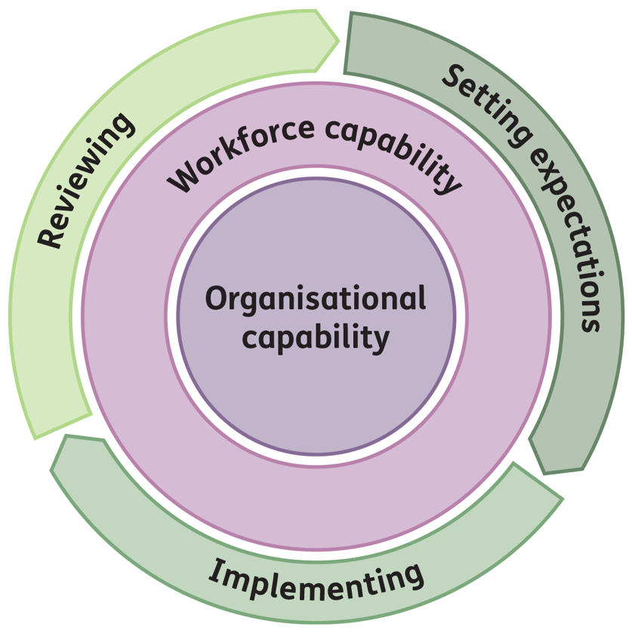
What | Why | Resources
Setting expectations | Organisations are responsible for establishing conditions where workers can develop and thrive. Senior managers and leaders are responsible for the workplace culture, systems, policies and practices that support workers in delivering quality support. Supervision is a key element to support implementation. | Systems to Support Supervision: a guide for organisations on the management systems and organisational capabilities needed to support and manage a capable workforce.
 | Workers need a clear understanding of expectations. This includes understanding how their work fits with the organisation’s purpose, understanding broad responsibilities, capabilities needed and how they will be supported by their supervisor/organisation. | Supervision and Support Relationship: a guide to establishing the worker-supervisor relationship to agree on performance expectations, set supervision and development priorities and set up processes for discussing issues and tracking progress.  Learning and Capability Development: a guide on how to identify, develop and assess capabilities. Individual capability development plans form part of the performance agreement.
Implementing | Workers and supervisors need to understand and respond to the specific needs of individual participants. | Working Together: a guide to three-way communication between the participant, worker and supervisor to reach a shared understanding of expectations and how workers can be supported to achieve them. Separate guides are available for supervisors, workers and participants.
Reviewing | This step is critical for understanding how well the worker is supporting participant needs, identifying worker strengths and areas in need of further support or development, and for assessing how well supervision is working.  Participants have a key role in providing feedback on what is going well and what could be improved or needs to change. | Systems to Support Supervision: a guide for organisations on the management systems and organisational capabilities needed to support and manage a capable workforce.

Other useful resources
- NDIS Workforce Capability Framework: describes the attitudes, skills and knowledge required by all workers – including supervisors – and the behaviours you can expect to see.
- Workforce Management and Planning Tool: a tool designed to support organisations to assess and plan current and future workforce needs and prioritise strategies, including learning and capability development plans.
- NDIS Code of Conduct: promotes safe and ethical service delivery by setting out expectations for the conduct of both NDIS providers and workers.
- NDIS Code of Conduct - Guidance for Service Providers
- NDIS Practice Standards and Quality Indicators: specify the quality standards to be met by registered NDIS providers to provide supports and services to NDIS participants.

